How to setup tailwind in a folder:

1st-> create a folder

2nd -> open Vs-code into the folder

3rd -> open the terminal of the Vs-code and type

(node -v) to check if the node js is installed in your pc pr not .

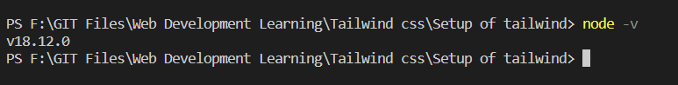

4th -> then in the terminal type (npm init -y) and this will give u a json file.

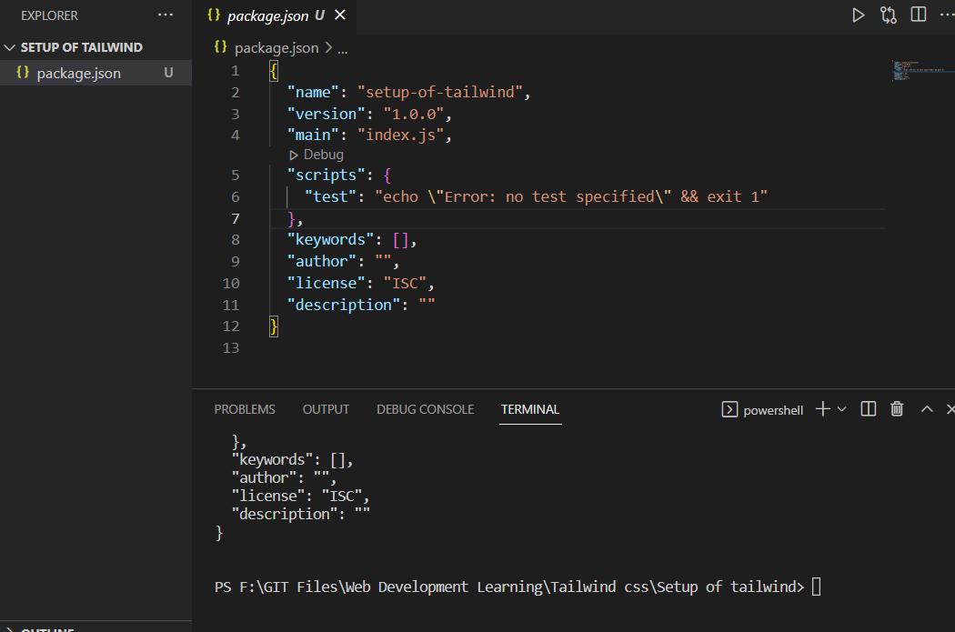

5th ->then type (npm install -D tailwindcss) in the terminal of the vs code to install some package

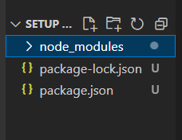

Then type (npx tailwindcss init) in the terminal of the vs-code and



And this will give us a tailwind.config.js

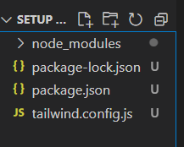

Then type ( **‘./*.html** ’) in the content of the tailwind.config.js

After that create a **input.css** file in the vs code and insert

@tailwind base;

@tailwind components;

@tailwind utilities;

In to the input.css

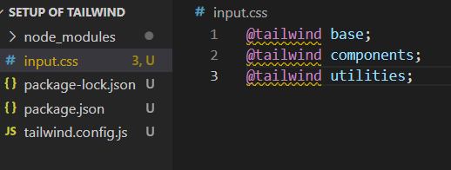

After that go to the package.json

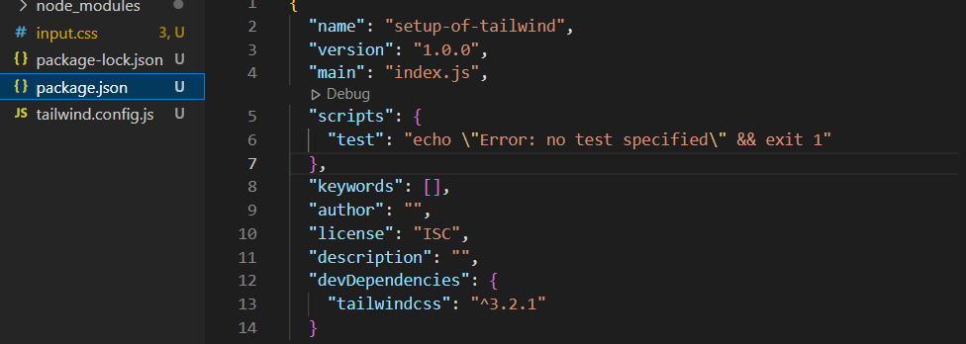

and there change “test” of the “script” into “build”

In the build type(“ tailwindcss –i ./input.css –o ./css/main.css”) and again create a new build name as watch and there type(“ tailwindcss –i ./input.css –o ./css/main.css --watch” )

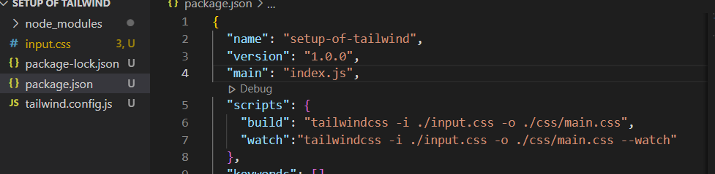

Then go to the vs terminal and type (npm run build )

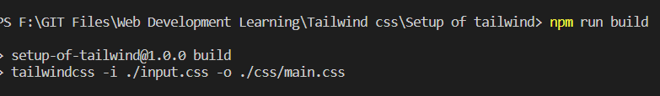

And this will give us main.css and this main.css is the output of input.css

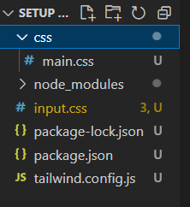

After that create a html file and link it to the (css/main.css)

And in the terminal write ( npm run watch) to rebuild all the tailwind tags

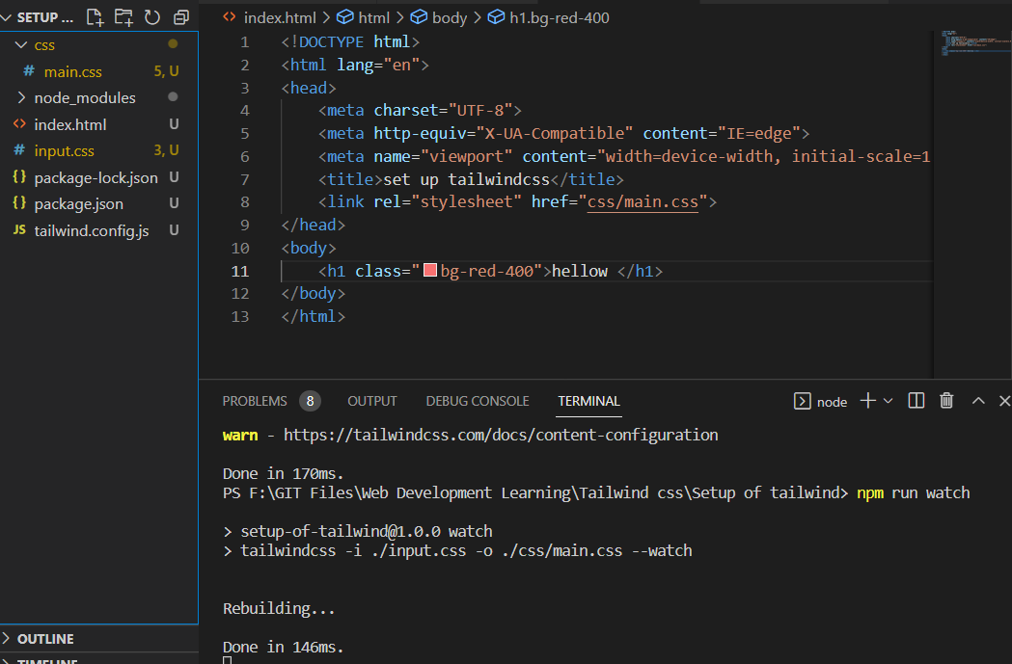

Vs-code doesn’t recognize the json file so that we should change some settings in the vs-code and type

"css.validate": false,

"tailwindCSS.emmetCompletions": true

Into the settings.json